**GamingPE Integrations**

**Field:**

|  |  |  |  |
| --- | --- | --- | --- |
| **Parameter** | **Description** | **Mandatory** | **Comments** |
| **userId** | Your User Id that you get it after login | Yes | Value should be your user **_id** Get it from login request |
| **amount** | Transaction amount | Yes |  |
| **category** | it is used for transaction amount filter | Yes | Value should be **P1,P2,P3,P4,** **Default : P1** |

Following are the meaning of statuses you will get

1. **success** means Transaction is successful.

2. **page_viewed** means transaction is pending

3. **utr_not_submitted** means transaction is failed.

4. **processing** means transaction is failed.

5. **failed** means transaction is failed.

**How to access our portal:**

**1- Login** by credential that we provide you to  
<https://api.payz365.com/auth/login> as **POST** request include **email** and **password** inside body

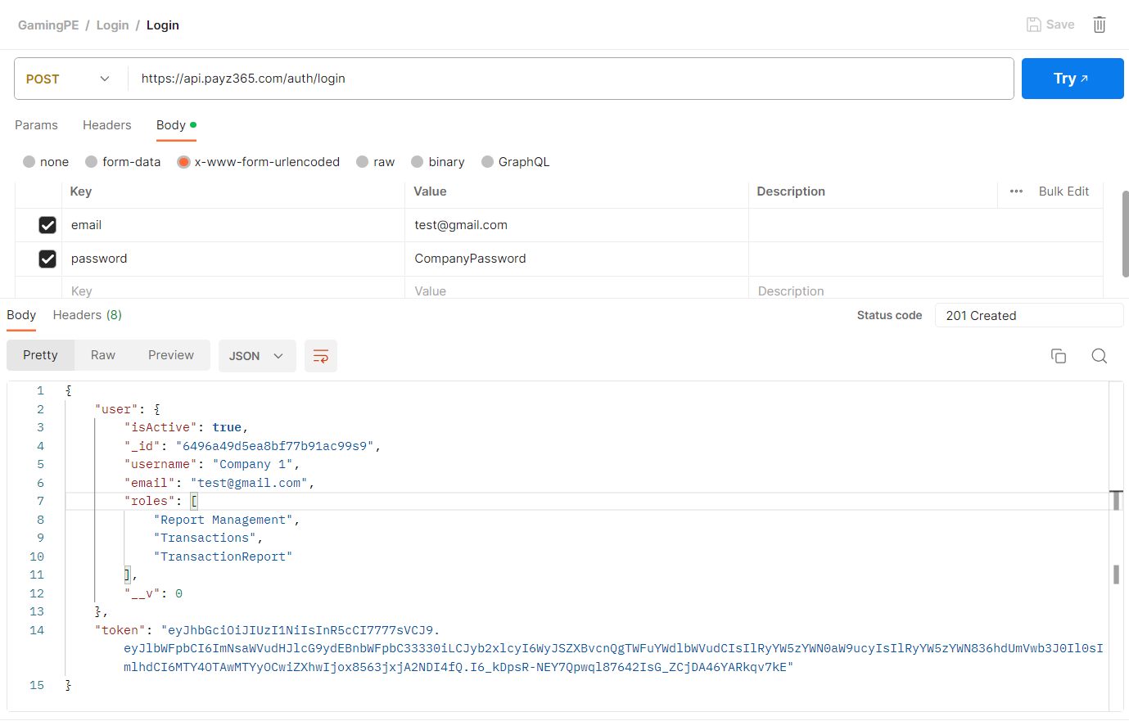

**2- Crete Transaction**   
send POST request include transaction data in body + Bearer token in Authorization in header

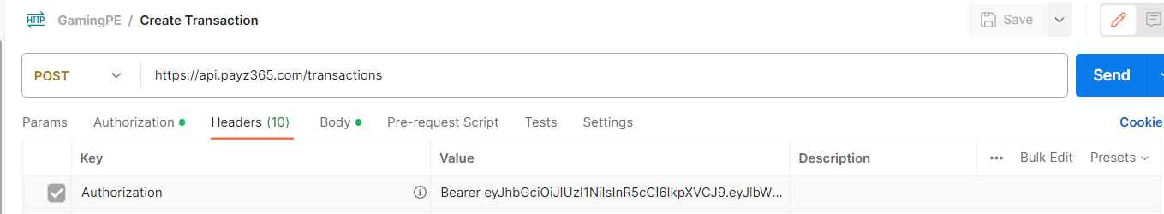

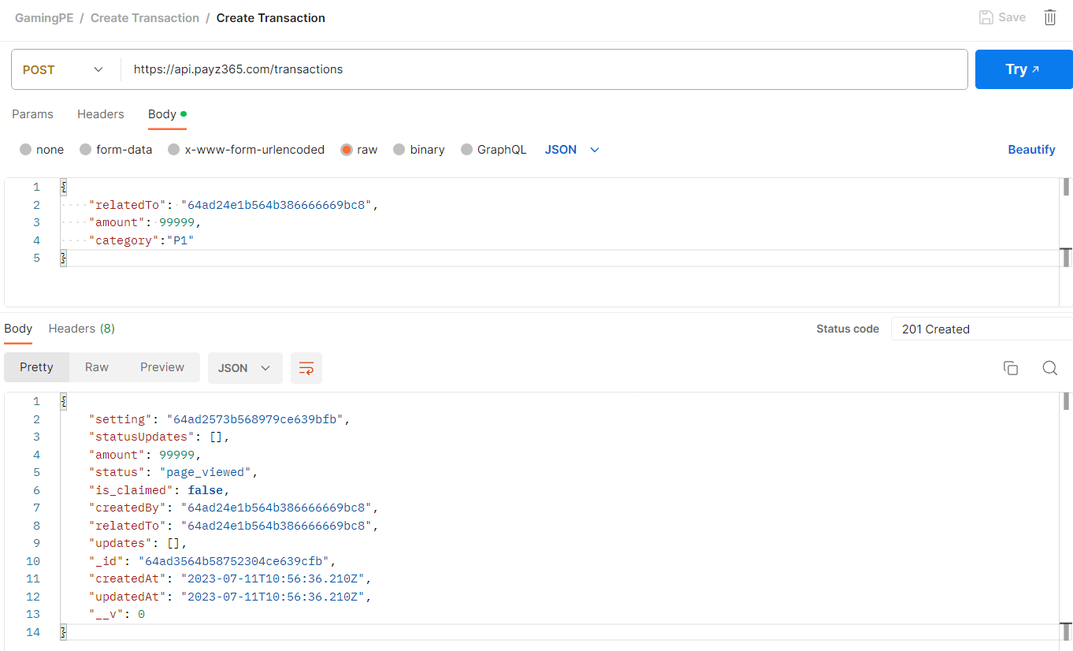

**Notes**:

* RelateTo is user **_id** got it from login response
* Our system will send request to callback_url as POST request when the status updated

**3- Redirect Client to transaction page**

You will redirect client to redirect page after create transaction will get **_id** from its response and redirect client to   
[https://pay.payz365.com/transactions/{_id](https://pay.payz365.com/transactions/%7b_id)}

Replace _id by transaction _id like

[https://pay.payz365.com/transactions/**64ad3564b564b384ce639cfb**](https://pay.payz365.com/transactions/64ad3564b564b384ce639cfb)

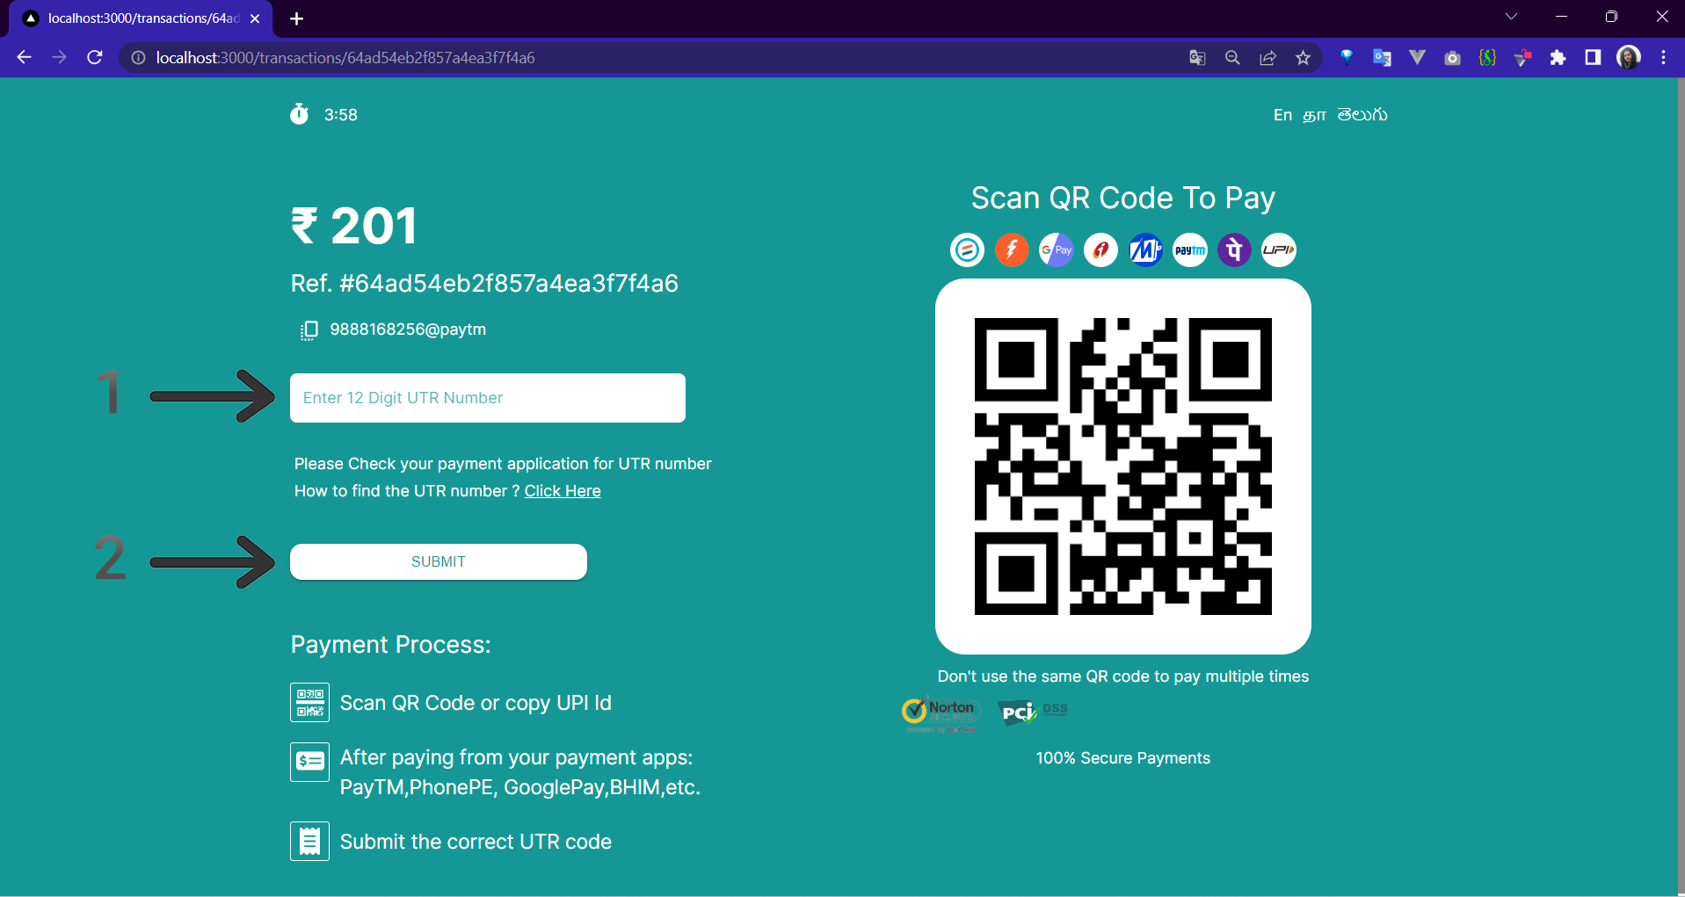

**4- Receive transaction update on your call back URL that you provide us**

**Status flow**   
